# **Weekly Report – W12 Spring 2023**

## **Task & Problem**

1. Apply the “algorithm” to real time data collection code to see it can deal with the sharp angle change issue;
2. Try to apply different kinds of filters to decrease the noise of angular velocities;
3. Design some additional parts to fix the global coordinate IMU onto the backpack, meanwhile consider the wiring route.

## **Solution**

1. Implant the algorithm from post data processing to real time data collection

#### (1). Deal with sharp angle change issue

Last week I have briefly introduced my algorithm in the report, and it succeeded in the post data processing section, and this week I modified the code a little bit to make it applicable to the real time data collection, it worked for most cases, the specific effect is shown below.

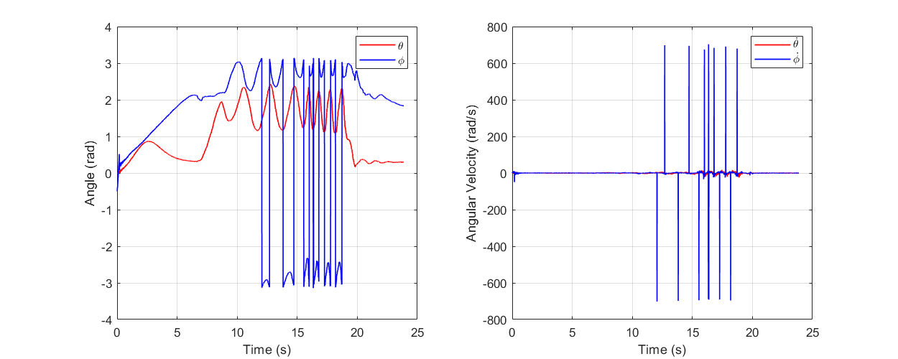

**Fig. W12-1** The real time data collection without algorithm

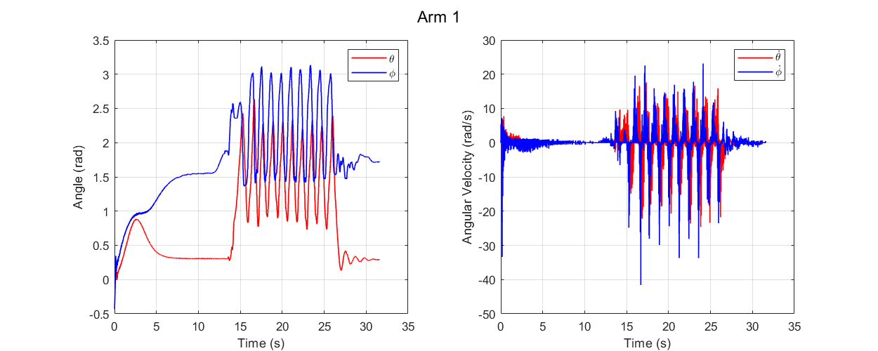

**Fig. W12-2** The real time data collection with algorithm

However, the motion in the two figures above was in the plane which is perpendicular to the plane that the global coordinate IMU was mounted. Soon I found my algorithm was not applicable for more complex motion, for a combination motion in both perpendicular and parallel direction with respect to the global coordinate IMU plane, the negative values still would appear for some reasons, so far I haven’t come up with a better solution to deal with this issue, and an example is shown as follows.

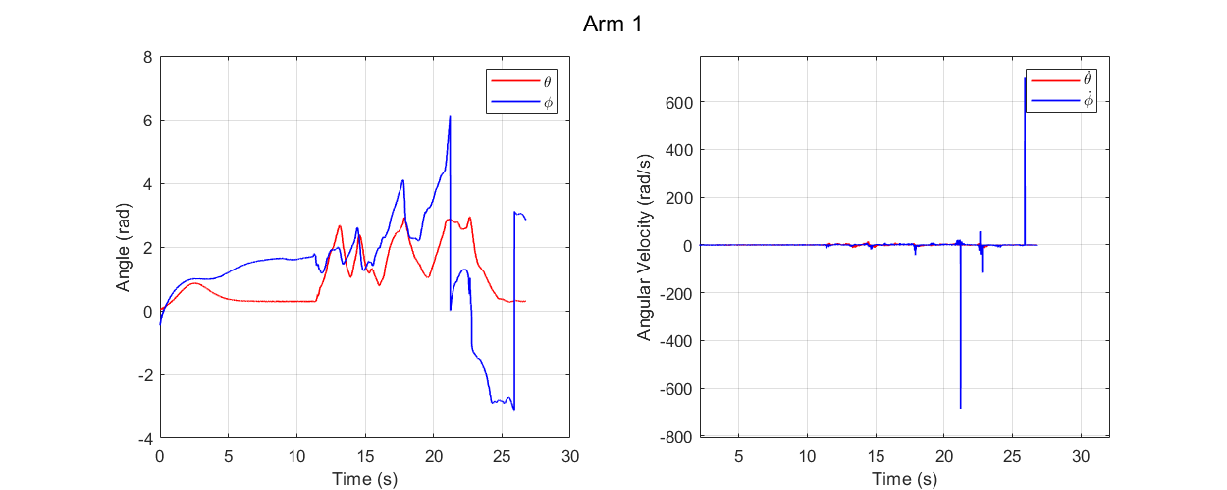

**Fig. W12-3** The sharp angle change issue still exists even with the algorithm

As shown in the figure above, at some points in the 3D space, the angle will drop down to a location that the $ϕ$ angle is very close to zero but great than zero, in this case my algorithm will not work, and the data collection after this point will all be wrong.

#### (2). Explore the magnetic field effect

As shown in the figure below, the wiring method will generate two magnetic fields which are pretty close to the IMU, and rightly the IMU used in our experiment is 9-axis, which means that it will be affected by the magnetic field to some extent.

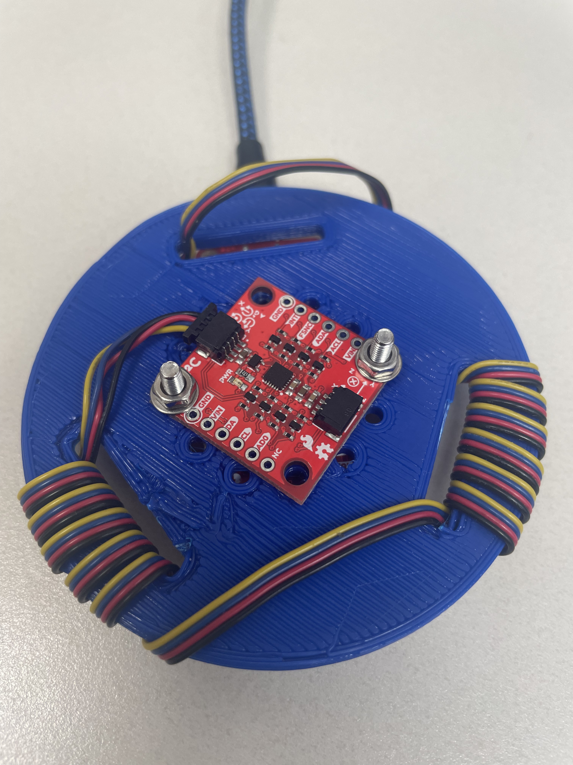

**Fig. W12-4** The wiring method for the IMU and ESP32 assembly

And it has proved that compared to the original state (the IMU and ESP32 were not assembled together by the blue plate), it will take about 10 s for the response to be stable when the whole system is stationary, the results can be seen in the figure below.



**Fig. W12-5** The real data collection after 10 s stabilization time

To verify if the magnetic field’s influence to the response, I did the following two groups of tests:

* When the power is on, I move the arms instantly and continuously until the test is end;
* When the power is on, I move the arms instantly for about 2 s, then let it be stationary for another 2 s, then do the same motion afterwards until the test is end.

And the corresponding test results are shown as follows,

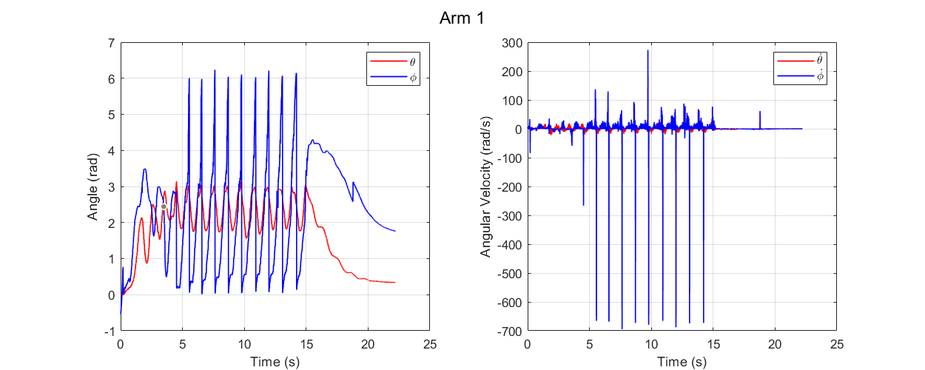

**Fig. W12-6** The results for test 1: continuous motion after the power is on

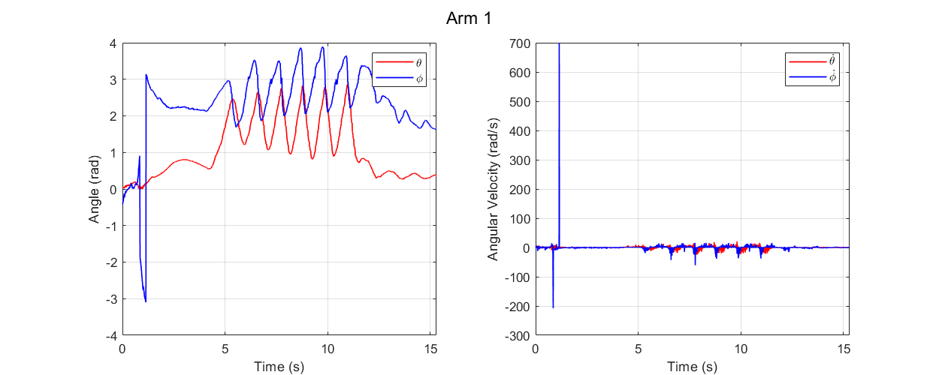

**Fig. W12-7** The results for test 2: continuous motion after the power is on with a short pause in the middle

It can be seen that without letting the system come to stable will make the data collection error even larger, especially for test 1; by pausing a short period, the error will significantly drop down, but there is still a huge error between test 2 and Fig. W12-5. So temporarily I haven’t found any better solution to eliminate the magnetic field’s influence by coding, we can wait 10 s for the system fully come to stable and then begin our experiment.

1. Deal with noise and drifting errors for the angular velocities

As shown in all the figures above, there will be a lot of noise for the velocities, in the real time experiment, we would like to eliminate these noise and some drifting errors as much as possible to give the controller a better and more clear command. So this week similar to the process for dealing with sharp angle issue, firstly I add different filters to the final results, and evaluate their effects and then implant the filter into the real time data collection code.

However, when I implanted my code, I found that the noise hasn’t been got rid of, the application of the filter will bring in serious drifting errors as shown in the figure below. And I have tried smooth filter and Kalman filter, the effects were not so good. Maybe next week I can consult Miao for some suggestions.

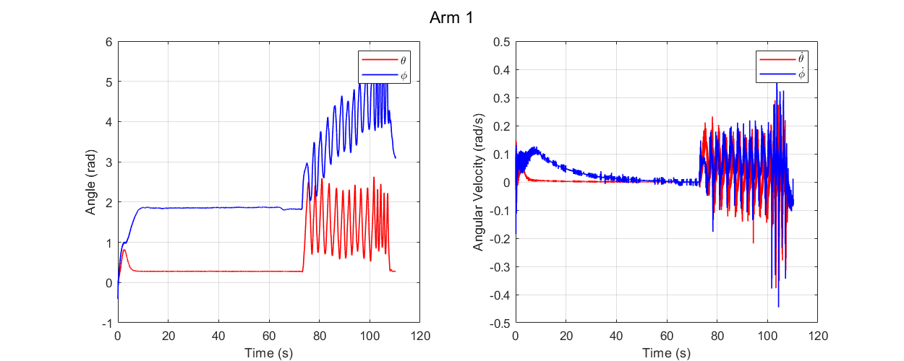

**Fig. W12-8** The real time data collection with a smooth filter

1. 3D design to fix the global coordinate IMU

Since there is not so much progress with the filter, I think I can do something else might be useful to our project, to eliminate the issue caused by mechanical devices as much as possible; and on the other hand, I have seen too many failures during Miao’s experiments, so it’s necessary for me to make a thorough preparation before real experiment.

My design is shown as follows, the ESP32 will be fixed using the similar method for the IMU and ESP32 plate designed last week, and the IMU will be mounted parallel with the vertical wall of the backpack as requested by Manu. The innovative part of the design is the wiring method, the wire will go along the groove in an “S” shape for several time and then it will be compressed tightly by the “hat” above, the fundamental principle is to utilize the friction to decrease the influence of traction force generated when the arm is stretched and to protect the port and make sure a well connection of electronic devices during the experiments.

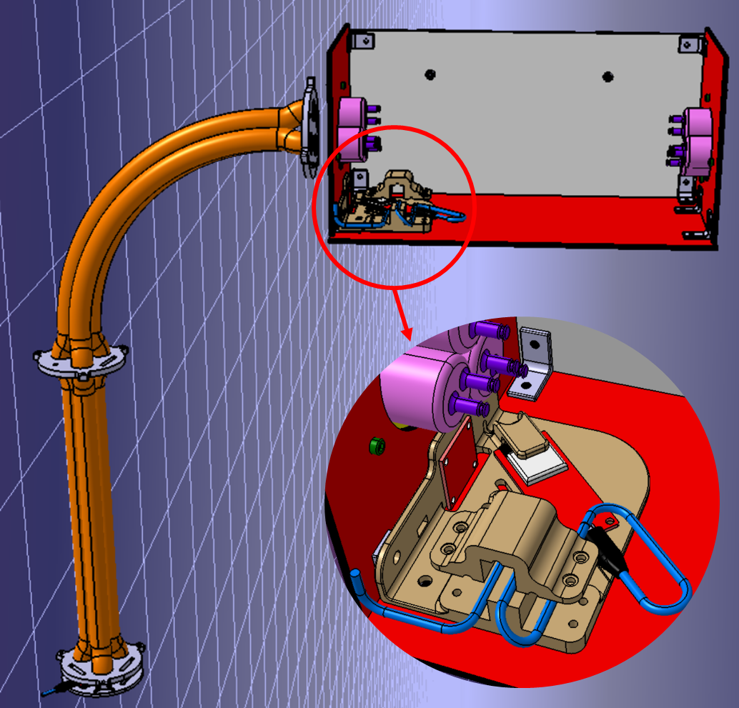

**Fig. W12-9** The schematic of the 3D design for fixing global coordinate IMU